Habitat AI
An AI, Blockchain and Cybersecurity Powered Property Planning Ecosystem

Base Paper:
Home Interior Design Suggestion System using Deep Learning
IEEE ICCCNT 2024
DOI: 10.1109/ICCCNT61001.2024.10726122

Team Members:
Anisha Paturi - 23BD1A050E
Ch Parinamika Bhanu - 23BD1A0518
Ch Venkata Vahini - 23BD1A051D
Sravani Janak - 23BD1A051Y

Mentor Name:
DR. VISHAL REDDY

INTRODUCTION
The rapid advancement of Artificial Intelligence has transformed the field of interior design and architectural planning. Recent deep learning models such as YOLOv8, Stable Diffusion, ControlNet, and DeepFill enable automatic furniture replacement, object removal, and AI-generated room designs.
However, current AI interior design systems are limited to modifying existing room images and providing visual suggestions. They do not support complete property planning workflows such as land suitability analysis, ownership verification, financial planning, construction simulation, or secure property management.
Habitat AI extends the capabilities of existing interior design systems by integrating GIS Intelligence, Blockchain Technology, AI Financial Planning, Cybersecurity, and Digital Twin technologies into a unified property planning ecosystem.

PROBLEM STATEMENT
Current challenges include:
- Fragmented property planning process
- Multiple disconnected services
- High construction costs
- Budget overruns
- Poor land utilization
- Property document fraud
- Lack of financial planning
- Complicated government approvals
- Absence of real-time visualization
There is currently no integrated platform capable of addressing all these challenges simultaneously.

BASE PAPER SUMMARY
Paper Title
Home Interior Design Suggestion System using Deep Learning
What the Paper Does
The proposed system allows users to:
• Replace furniture or objects in room images
• Remove unwanted objects
• Generate new interior designs from text prompts
Technologies Used
• YOLOv8
• Stable Diffusion
• ControlNet
• DeepFill
• Computer Vision
• Deep Learning
Output
AI-generated interior room designs and furniture suggestions.

REASEARCH GAP ANALYSIS
Existing Paper | Habitat AI
Works only on existing room images | GIS-based Land Intelligence Engine
Interior design only | End-to-End Property Planning
No ownership verification | Blockchain Property Registry
No financial planning | AI Financial Agent
No cybersecurity | Secure Property Protection Layer

PROPOSED SOLUTION
Habitat AI is a unified Property Planning Ecosystem that provides:
AI Architect
- Floor plans
- Space optimization
- Layout generation
Interior Design AI
- Furniture planning
- Theme generation
- Smart home recommendations
Uses
• YOLOv8
• Stable Diffusion
• ControlNet
• DeepFill
Provides
• Object Replacement
• Object Removal
• Furniture Suggestions
• Theme Generation
• Room Redesign
This directly extends the IEEE paper instead of replacing it.
GIS Intelligence Engine
- Terrain analysis
- Infrastructure analysis
- Land suitability prediction
Financial Agent
- EMI planning
- Loan recommendations
- ROI estimation
Blockchain Registry
- Property ownership
- Smart contracts
- Document verification
Cybersecurity Layer
- Fraud detection
- Threat monitoring
- Secure document vault
Digital Twin Engine
- 3D visualization
- Virtual walkthrough
- Construction simulation

NOVEL CONTRIBUTIONS
Novelty 1
GIS-Based Land Intelligence Engine
Paper:
Works only on interior room images.
Habitat AI:
Analyzes empty land using:
• Terrain
• Climate
• Connectivity
• Infrastructure
Output:
Property recommendations before construction.

Novelty 2
Blockchain Property Registry
Paper:
No ownership verification.
Habitat AI:
• Polygon
• Solidity
• IPFS
• Smart Contracts
Provides:
• Ownership Security
• Fraud Prevention
• Tamper-proof Records

Novelty 3
AI Financial Planning Agent
Provides:
- EMI calculations
- Loan recommendations
- ROI analysis
- Construction budgeting
Contribution
Adds FinTech decision intelligence.

Novelty 4
Interactive Digital Twin
Provides:
- Real-time 3D models
- Construction simulation
- Virtual walkthroughs
Contribution
Transforms theoretical digital twins into practical implementation.

SYSTEM ARCHITECTURE
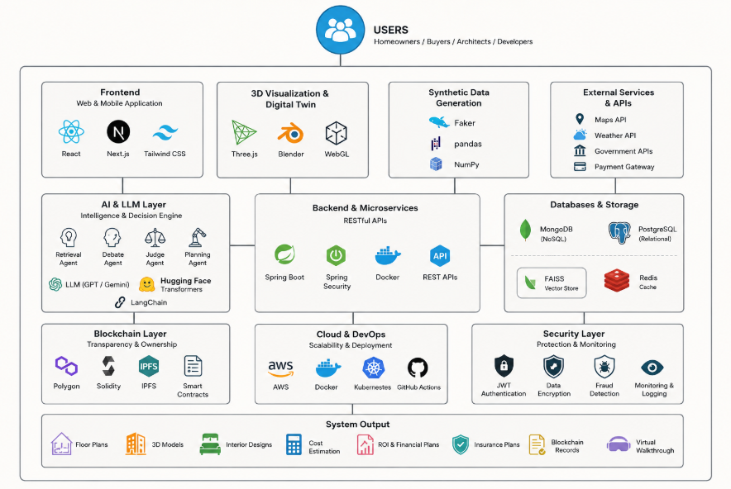

TECHNOLOGY STACK

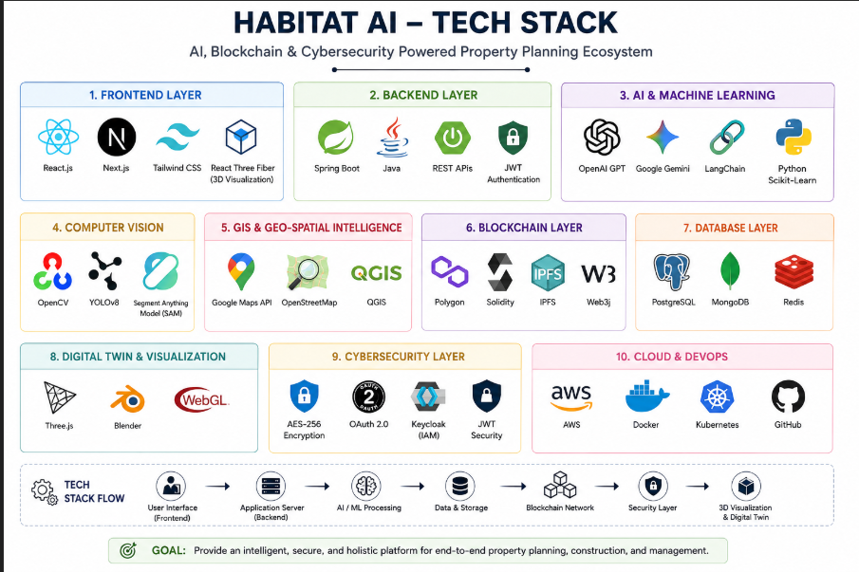

Habitat AI Tech Stack

Frontend Layer
- React.js
- Next.js
- Tailwind CSS
- React Three Fiber (3D Visualization)

Backend Layer
- Spring Boot
- Java
- REST APIs
- JWT Authentication

AI & Machine Learning
- OpenAI GPT
- Google Gemini
- LangChain
- Python
- Scikit-Learn

Computer Vision
- YOLOv8
- Stable Diffusion
- ControlNet
- DeepFill
- OpenCV
- Segment Anything Model (SAM)

GIS & Geospatial Intelligence
- Google Maps API
- OpenStreetMap
- QGIS

Blockchain Layer
- Polygon
- Solidity
- IPFS
- Web3j

Database Layer
- PostgreSQL
- MongoDB
- Redis

Digital Twin & Visualization
- Three.js
- Blender
- WebGL

Cybersecurity Layer
- AES-256 Encryption
- OAuth 2.0
- Keycloak
- JWT Security

Cloud & DevOps
- AWS
- Docker
- Kubernetes
- GitHub

EXPECTED OUTCOMES
Habitat AI aims to:
- Reduce planning cost by 40–60%
- Improve land utilization
- Reduce documentation fraud
- Improve financial decision making
- Simplify property lifecycle management
- Enable immersive property visualization
- Automated Interior Design Generation
- AI-Powered Room Redesign
- Smart Furniture Recommendations
- Reduced Design Consultation Cost

PUBLIC POTENTIAL
The proposed work introduces four major research contributions:
- GIS-based Land Intelligence
- Blockchain Property Registry
- AI Financial Planning Agent
- Interactive Digital Twin Simulation
These extensions significantly expand the scope of the base paper and provide sufficient novelty for future conference or journal publication.

